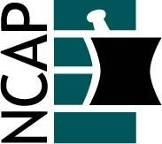

North Carolina Association of Pharmacists
2020 – 2021 New Practitioner Forum

Brianna Berish (Chair)  (845) 825-2657  Brianna.berish@gmail.com | Tyler Vest (Vice Chair)  (919) 937-8118  Tyler.vest@duke.edu
Riley Bowers (At-large)  (919) 748-2706  bowers@campbell.edu | Carrie Baker (At-large)  (814) 889-1158  Cnbaker0830@email.campbell.edu
Taylor McDaniel (At-large)
(336) 409-6684
Tnmcdaniel1015@email.campbell.edu

