OPIOID EMERGENCY  ACTION PLAN  SIGNS OF AN OPIOID EMERGENCY  - UNRESPONSIVENESS  Cannot wake up with a loud voice or by rubbing firmly on the middle of their chest  - PINPOINT PUPILS The black circle in the center of the colored part of the eye (pupil) is very small  - SLOWED or STOPPED BREATHING  - PURPLE OR BLUE COLOR TO LIPS AND FINGERNAILS  - CLAMMY SKIN  - PALE FACE  - LIMP BODY  - VOMITING  Only a few signs may be present. However, they can get worse quickly and can be life threatening.  ACT FAST! | Accidental Opioid emergencies can cause life-threatening breathing problems. Have Naloxone available at all times  HAVE AN OPIOID EMERGENCY PLAN IN PLACE  Educate and prepare family members, friends or caregivers by making sure they  - Know the signs of an opioid emergency  - Know the instructions for preparing and using Naloxone  - Know where naloxone is kept in case of an emergency  This Action Plan is for: _____________________________________  Opioid(s) Used: _____________________________________  Other “medications” that increase my risk are… _____________________________________  My “conditions” that increase my risks are… _____________________________________  “I keep my Naloxone” … _____________________________________  If you have questions or need a replacement naloxone please contact us at  INSERT PHONE OR CONTACT INFORMATION  INSERT Pharmacy LOGO HERE  EMERGENCY ACTION STEPS  - CALL 911  - GIVE NALOXONE  (Type: ☐ Nasal spray ☐ Nasal spray with assembly ☐ Injectable naloxone  - REPEAT in 3 minutes if no response  - Do rescue breathing or chest compressions  - Stay with person until help arrives
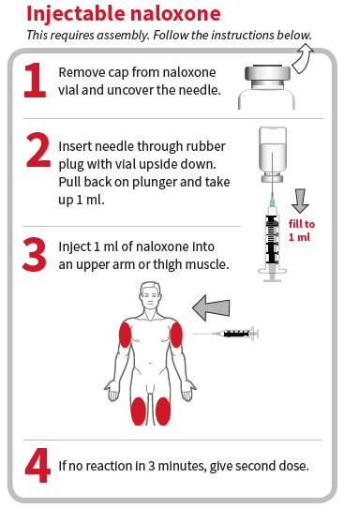
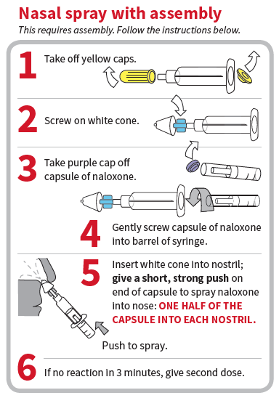
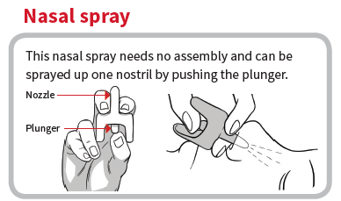

Accessed from the SAN FRANCISCO DEPARTMENT OF PUBLIC HEALTH
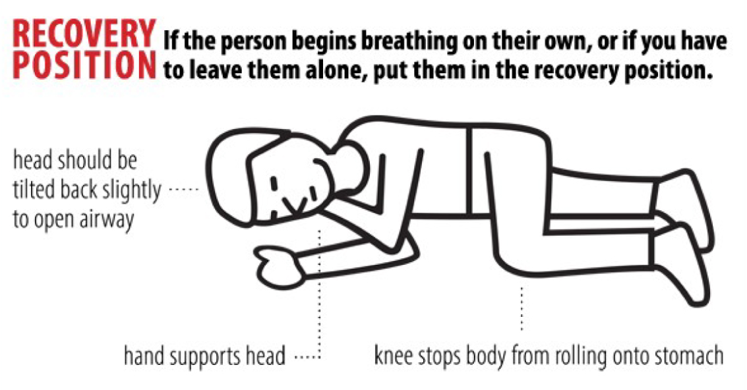
https://prescribetoprevent.org/wp2015/wp-content/uploads/NaloxonePatientFlyer_SFDPH_2016.pdf

Injectable naloxone – ZIMHI™

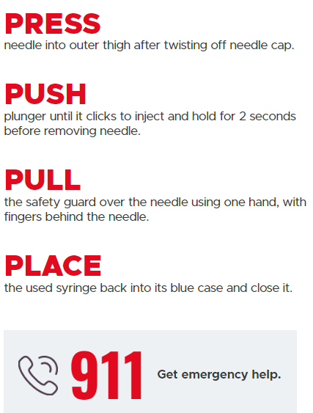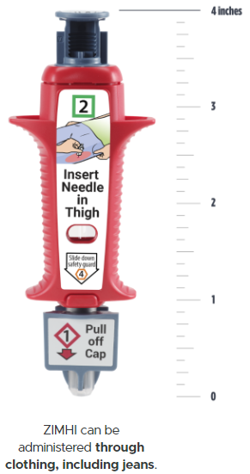

Accessed from ZIMHI/Pharmacists/How to Use https://zimhi.com/pharmacists-how-to-use-zimhi /

