Submitting an Appeal to the Offending PBM

A Few Key Reminders:
- Contact the PBM first to resolve the issue directly - the appeal process is required for below cost reimbursement.
- Check applicable appeal timelines where relevant (e.g., MAC appeals)
- Each PBM has an appeals process (website - online portal, email, telephone #) with specific required data.
- Consider implementing daily, bi-weekly, or weekly audits of prescription claims to identify and submit appeals.
- If there is no response or an unfavorable one within the specified time frame, then submit a violation to NC DOI
Submitting an Appeal to PBM in violation of SCRIPT Act:

- Navigate to the PBMs Appeals website portal or telephone/email.
Appeal Process
PBM | Link | Required Data
ESI | https://prc.express-scripts.com/#/account/login | - Rx #  - Date of service  - ACQ per unit  - Desired reimbursement per unit
Optum | https://business.optum.com/en/support/professionalrx-resources.html | - Rx #  - Filled date  - BIN  - NCPDP  - NDC  - Wholesaler  - ACQ per unit  - Net purchase price of drug  - Total reimbursement  - Drug name  - Drug strength
CVS Caremark | CVS Caremark | - Rx #  - BIN  - PCN  - NCPDP  - Fill Dare

Submitting a Violation of the Script Act (PBM Complaint) to the NC Department of Insurance (NCDOI)

A Few Key Reminders:
- Much of the Script Act went into effect on October 1, 2025.
- Most provisions apply to contracts entered into or amended on or after October 1.
- Section VI became effective immediately on October 1 and prohibits PBMs from reimbursing affiliated pharmacies at a higher rate than non-affiliated pharmacies.
- The Act applies only to health benefit plans as defined in § 58-3-167; federal plans (including Medicare and Medicaid) and the State Health Plan are not regulated under this law.
Submitting a Violation of the Script Act to NCDOI:

- Navigate to the complaint section of NCDOI’s website.

- Click the button Online Request Assistance/File A Complaint.
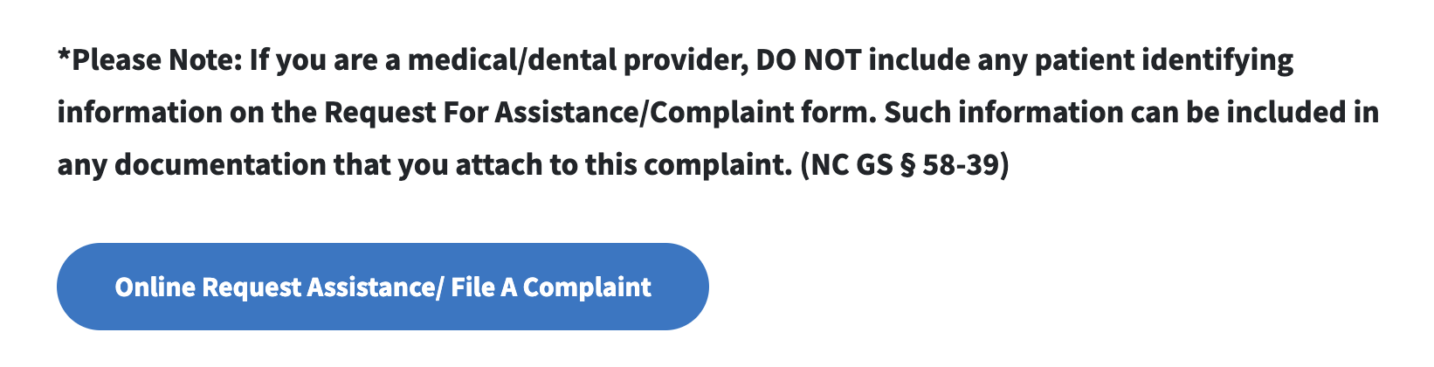

- Under Are you Represented by an Attorney, select No and then click Next.
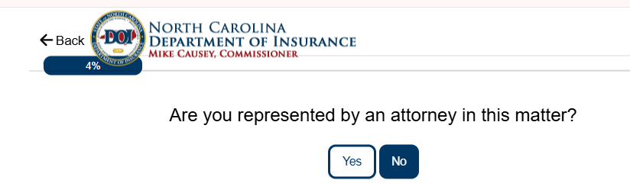

- Under Type of Complaint, select PBM and then click Next.
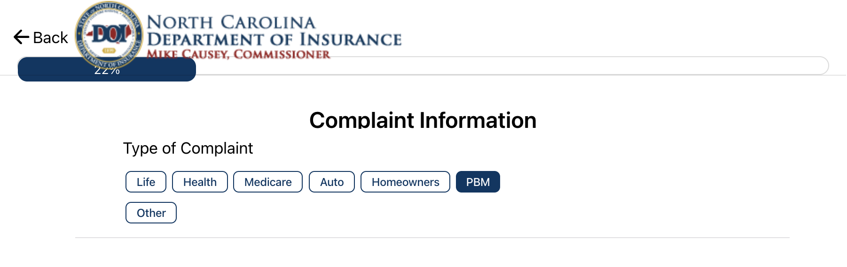

- Read through the information on the following screen and then click Next.
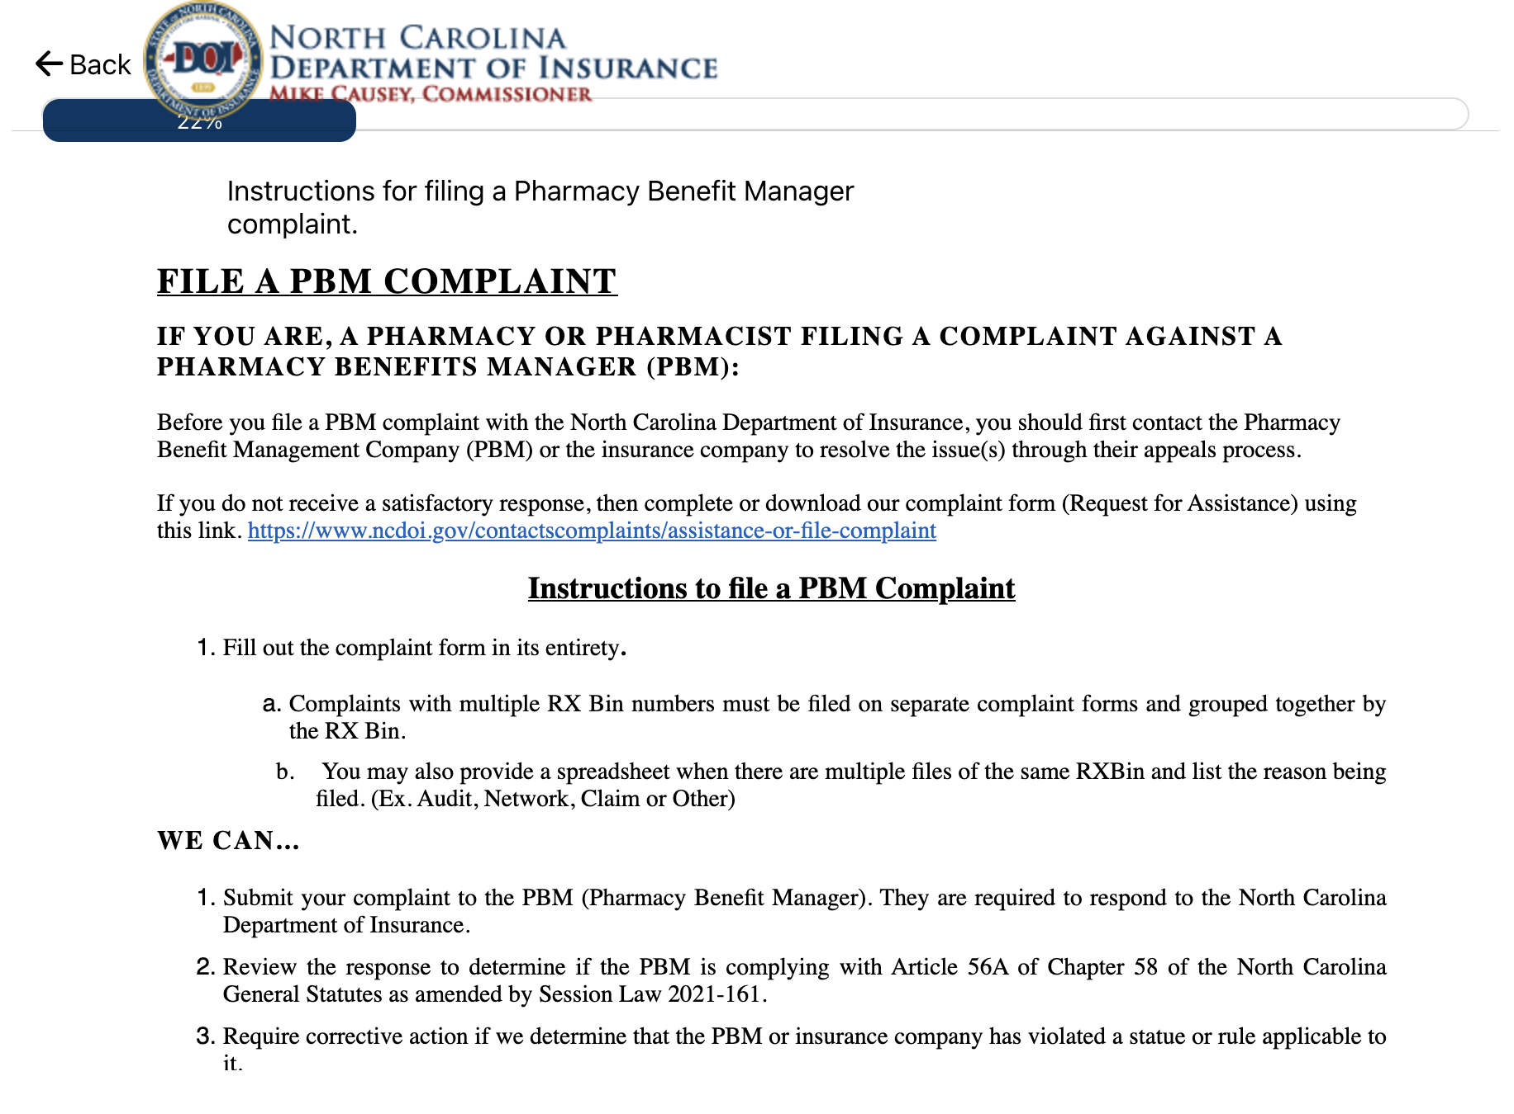

- Fill out your contact information and then click Next.
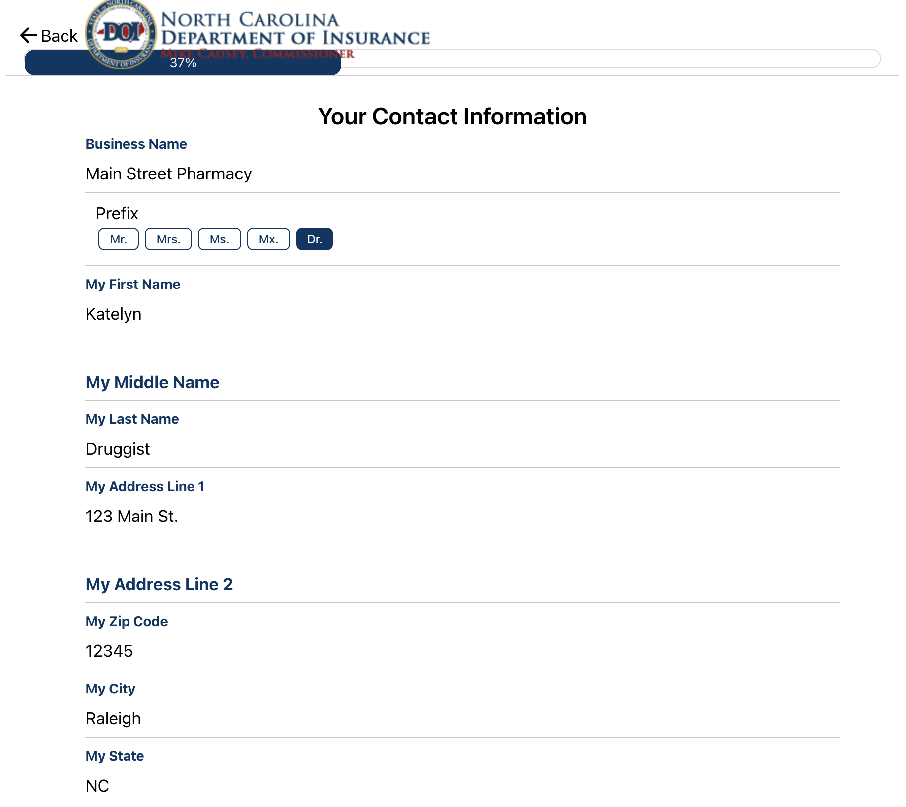

- Fill out your phone and email and then click Next.
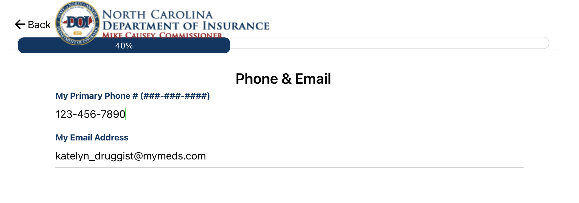

- Select Other and provide the specific area of the SCRIPT Act that the PBM has violated then click Next. Note: click here to access the SCRIPT Act to reference which Part is applicable to your complaint.
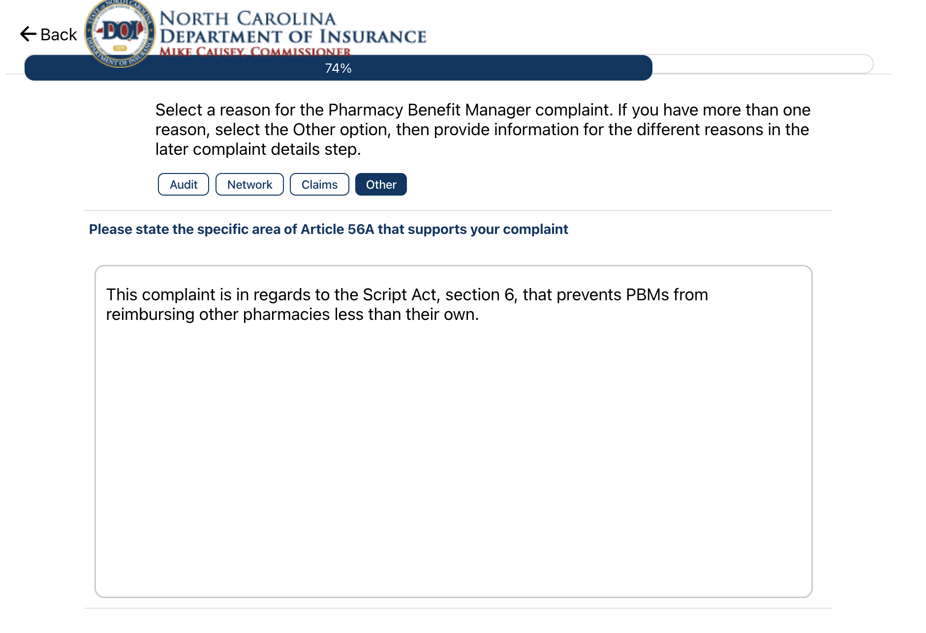

- Fill out the PBM information then click Next.
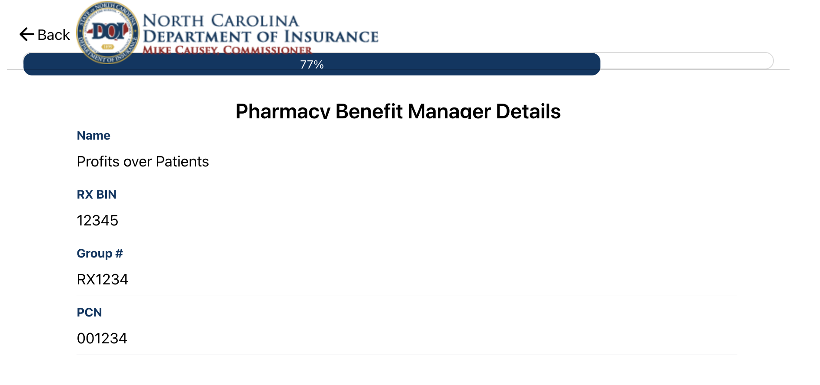

- Fill out the complaint details then click Next. Note: PBMs will request detailed information on the claim including, but not limited to: Member’s name, Member’s DOB, Drug name, Date of service, Prescription number, Description of issue and Member ID.

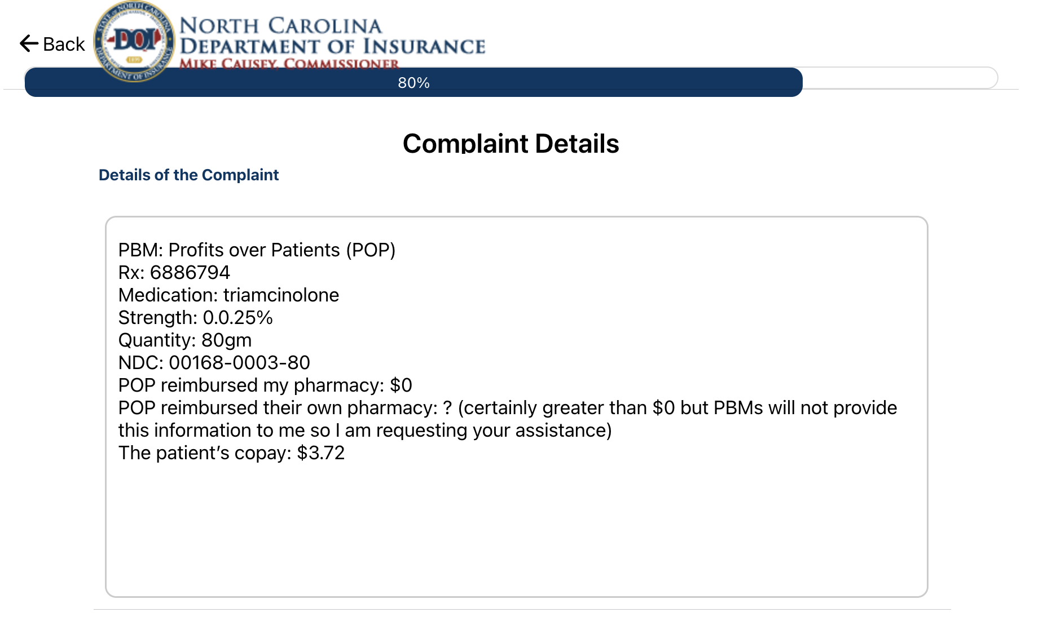

- Fill out the desired resolution then click Next.
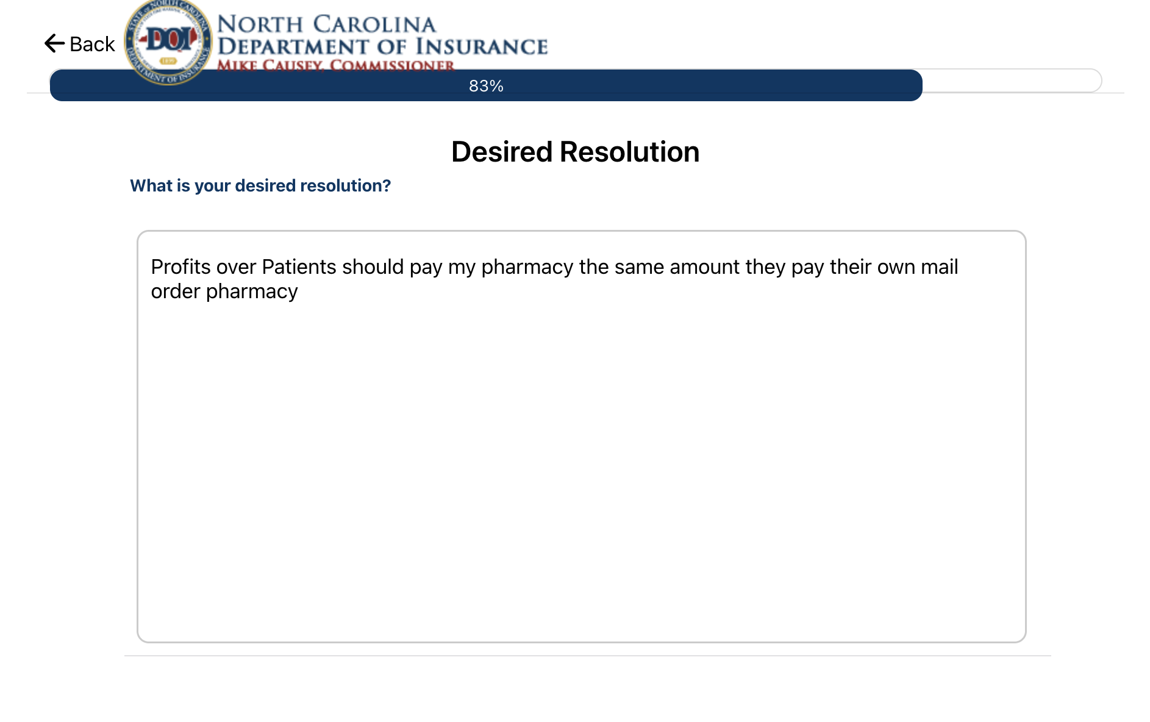

- Attach any supporting documents (e.g. POS screenshots, etc.) and then click Next.
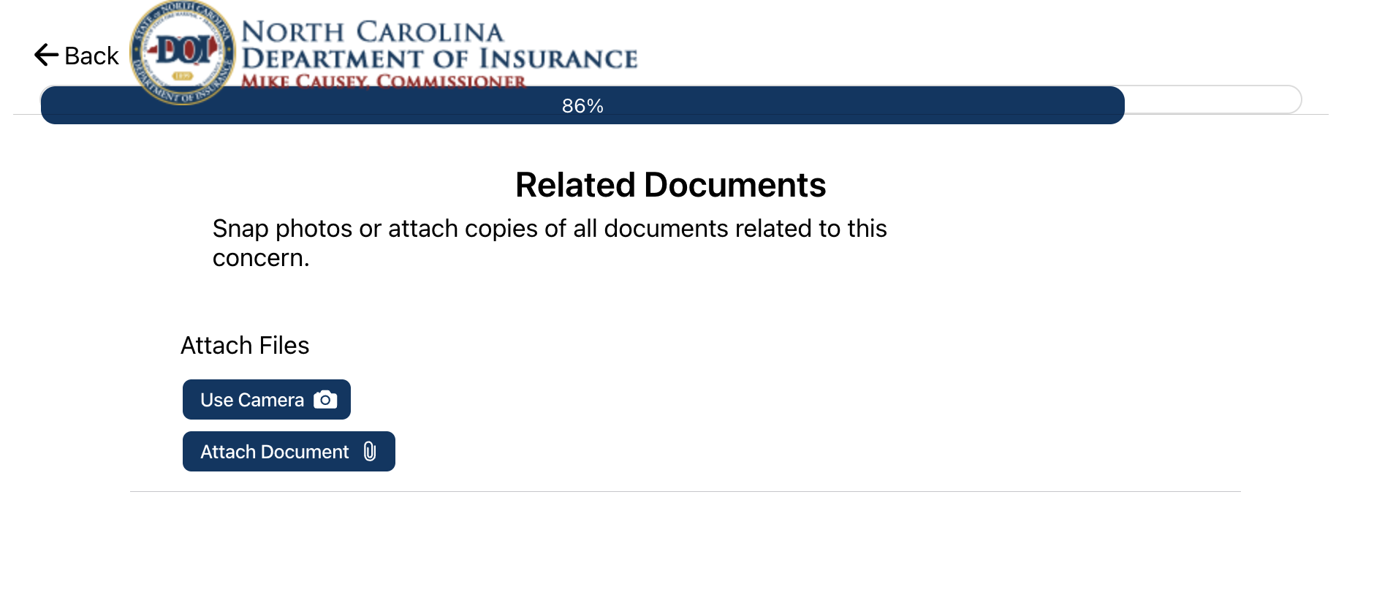

- Select your desired method of communication and then click Next.
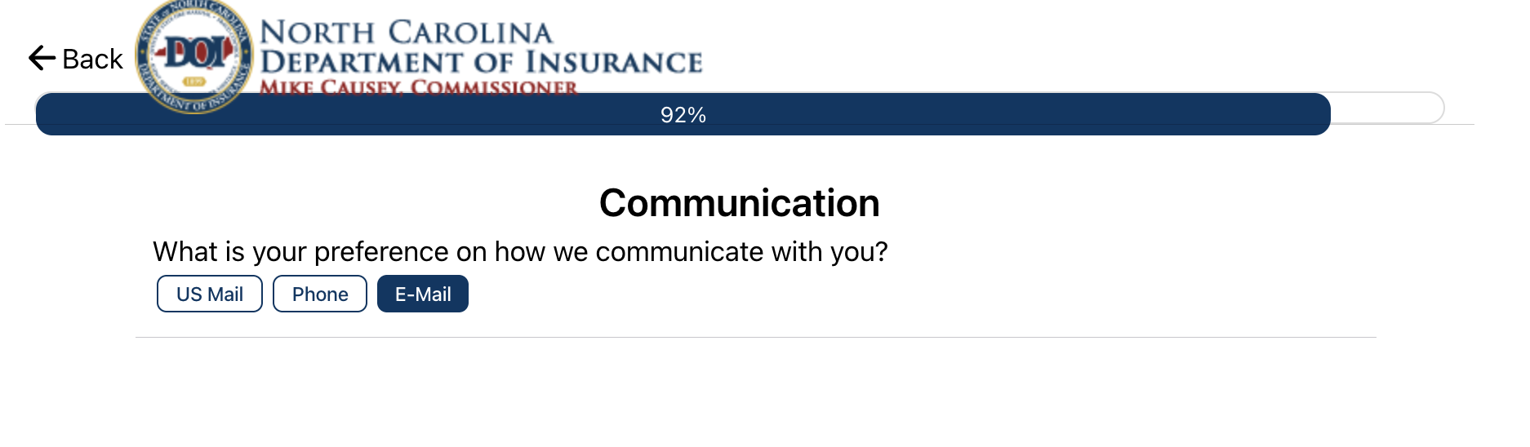

- Sign the authorization release and then click Finish.
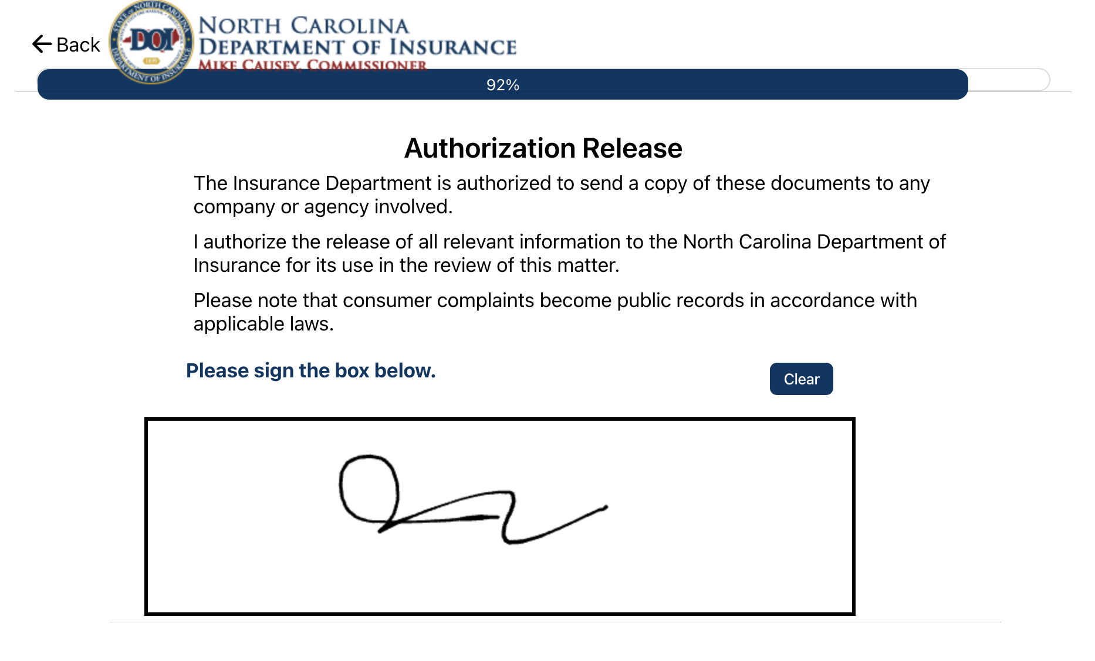

- A confirmation page will display as follows:
