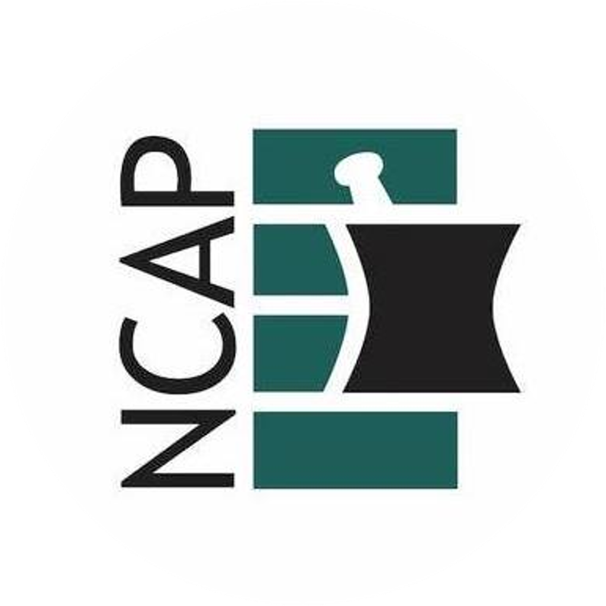
Pharmacy Benefit Managers
Talking Points

H246 Revise Pharmacy Benefits Manager Provisions
Primary Sponsors: Reps. Wayne Sasser, John Bell, Hugh Blackwell, & Chris Humphrey
- Pharmacy Benefit Managers are the middlemen between health plans and pharmacies and our patients. Each year, PBMs have become increasing more powerful and are the primary driver behind rising drug costs, so much so that PBMs continue to be the focus of attention in Congress, and the Federal Trade Commission. The Supreme Court case “Rutledge vs. PCMA” gave the states the ability to better regulate and rein in PBM unfair business practices that negatively impact patients and local businesses.
- H246 would help give the Department of Insurance authority to enforce PBM laws passed by the NC General Assembly.
- Reimbursement to pharmacies, for medications dispensed, is often at amounts less than what it costs the pharmacy to purchase the medication. Pharmacies have no say in the matter. Why? Because the vast majority of health plans, nationwide, use one of three PBMs, and the PBMs set the reimbursement. H246 would require PBMs to reimburse pharmacies in accordance with the National Average Drug Acquisition Cost (NADAC).
- H246 would eliminate ‘spread pricing’, which is when the PBM charges the health plan one price for a dispensed medication, reimburses the pharmacy a lower amount, and then the PBM pockets the difference with little to no transparency.
- PBMs have taken control over specialty medications, preventing our health-system medical clinics, from being able to provide medications in a timely and direct manner for patient care. Clinic and community pharmacies, that are already credentialed as ‘specialty pharmacies’, are often forced to obtain additional specialty accreditations, by a PBM, in order to be allowed to dispense these medications to patients under the PBM-administered health plan. H246 would keep PBMs from being able to require more than one specialty pharmacy accreditation.
- PBMs often force patients to use their mail order pharmacy. H246 would give patients more choice in where they get their medications and care.

Vote to support H246 Revise Pharmacy Benefits Manager Provisions
Questions: Please contact the North Carolina Association of Pharmacists (984) 439-1646

